Hydrolysis of an Alkyl Halide
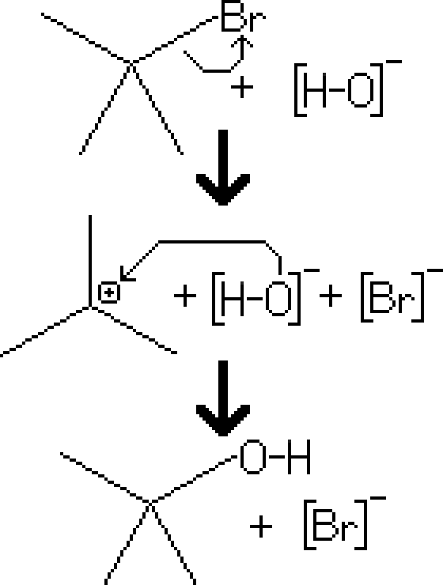
Reactants – Tertiary Alkyl Halide, H₂O
Products – Tertiary Alcohol, Br⁻
Electron Movement
- SN1 Reaction – The alkyl halide leaves the molecule, giving a carbocation intermediate. This allows the nucleophilic hydroxide molecule to attack it, resulting in an alcohol.
Notes
- Since the reaction is based on the SN1 mechanism, there are several conditions that may increase the rate of reaction
  - A substance in solution will have a higher rate of ionization if the solvent is polar protic.
  - For reactions involving alkyl halide reactants, halides with a larger radius will be an easier leaving group, and consequently will give the molecule a faster rate of ionization.
  - If the structure of the molecule allows for it, the reactant may restructure itself to lose steric strain (either with a hydride shift or a methyl shift)

